GIHÁPON: AN INTERACTIVE MULTI-ENDING

VISUAL NOVEL ADVENTURE GAME

An Undergraduate Thesis

Presented to the Faculty of the

College of Information and Communications Technology

West Visayas State University

La Paz, Iloilo City

In Partial Fulfillment

of the Requirements for the Degree

Bachelor of Science in Entertainment and Multimedia Computing

by

Chemar Kristine N. Benitez

Ma. Jessreigna G. Collado

Eisaac C. Hibionada

John Cristian V. Suarez

Andrea E. Villamor

JUNE 2023

CHAPTER 1 INTRODUCTION OF THE STUDY

Background of Study

People have been telling stories since the advent of language and art, but due to a clever, fascinating, technological innovation called video games, the history of storytelling has grown exponentially in the last 40 years. Art, music, performance, science, and, perhaps most importantly, writing is combined in video games. Several video games have been acclaimed for their innovative storytelling techniques, and one genre is finally gaining attention and acceptance in the gaming community called visual novels.

Visual Novel (ビジュアルノベル, abbreviated as VN) is an interactive fiction video game genre (Cavallaro D., 2010) featuring a story in a narrative style of writing and interactivity that utilizes music, photos, live-action stills, and occasionally even with short video footage. The narrative found within visual novels either follow a linear storyline or branch off into different timelines. Puzzles, quests, and game modes are frequently embedded within the game to further the story and gameplay time.

Visual novels are extremely common in Japan, where they accounted for about 70% of all PC game titles produced in 2006 Anime News Network, 2006), and they continue to increase over time. Manga and anime are frequently adapted from well-known visual novels. Clannad, Steins; Gate, and Fate/stay night are some examples.

The video game genre Adventure Game, also incorporates an interactive narrative in their gameplay. Rollings and Adams (2003) defines Adventure Game as a video game in which the player assumes the role of a protagonist in an interactive story driven by exploration and/or puzzle-solving. The gameplay elements of choosing your own path found within Adventure Games mesh well with the structure of Visual Novels. Major decisions that are made in the game affect the flow of the narrative which gives players the feeling of empowerment through their choices. Puzzle-solving elements found in adventure games not only provide additional gameplay but also when properly contextualized within the world and story of the game, gives a sense of immersion. Quantic Dream is a video game company known for developing cinematic quality adventure games with a rich narrative and include multiple endings. Their most recent release, Detroit Become Human, is a game that follows three android protagonists Kara, Markus, and Connor. This game features altering endings based around the choice made throughout the narrative, and even shows a detailed flow chart on the path the player takes in the story.

There is an untapped potential in the storytelling strengths of the Visual Novel Genre here in the Philippines. In terms of fans of the genre, there is only a niche following (Anime Pilipinas, 2015). On the other hand, in the context of Video Game Development here in the Philippines there are only a few Visual Novels that have been developed. An example of a Filipino made Visual Novel is Team Kwan’s “Exogenesis ~Perils of Rebirth~”. The game is about the leader of the renowned treasure-hunting team Durchhalten and Yuudai Sayashi who are on a journey to bring his sister back to life. Despite being Filipino made however, the game’s setting is not set in the Philippines. In that light, there is a gap not only in the Visual Novel Games, but also in Video Game development in general, of games set in the Philippines that features Filipino culture. There have been Filipino elements in other games such as Sega’s Yakuza, featuring a fighting style incorporating Arnis/Kali/Escrima sticks and also featuring a Filipino Character, however there is a lack of games set in the Philippines.

This study, entitled “Gihápon: An Interactive Multi-Ending Visual Novel Adventure Game” unpacked methods of developing a visual novel adventure game using Ren’Py Visual Novel Engine. The main goal of this study was to successfully develop an interactive visual novel game with narrative driven by character interaction and incorporating Adventure Game Genre elements such as multiple branching paths and endings featuring a story set in a fictional Filipino town with characters portraying various everyday Filipino traits. Homogenizing the two genres greatly benefits the interactivity aspect of our narrative and heightens the immersion of the players through the consequences of their choices affecting the flow of story.

Objectives of the Study

Generally, this research aimed to develop an interactive visual novel-adventure game with cohesive non-linear narrative multiple endings and branching paths based on the player’s choices.

Specifically, the study aimed to:

1. Add gameplay to the visual novel by developing a puzzle solving element between story beats, such as but not limited to code riddles and item-based puzzles.
2. Create and design a variety of dynamic characters with recognizable iconography that are related to the game plot and will aid the player's game progression.
3. Evaluate the final output using the Game User Experience Satisfaction Scale (GUESS).

Significance of the Study

This study aimed to provide entertainment and analytical purposes to the players. Creating and developing an interactive multi-ending visual novel adventure game to effectively train the analytical skills of the teenagers in solving puzzles.

This study would be a significant contribution and would be particularly beneficial to the following:

**Teachers and Professionals**. The findingsof this study may provide teachers and professionals with alternative educational platforms. The progress of this study can be used as a model, reference, and substitute.

**Students and Future Researchers**. The study's outcome may be used as a reference by future researchers who will conduct studies based on the methodology and theories used in the research.

Definition of Terms

For further clarification of the study, these terms were defined conceptually and operationally:

**Adventure Game** - is a video game genre in which the player assumes the role of a protagonist in an interactive story driven by exploration and/or puzzle-solving.

In this study, “Adventure Game” was the genre used for structuring the narrative in our output.

**Character-Driven Plot** - A story that is focused on studying the characters that make up your story. Character-driven stories can deal with inner transformation or the relationships between the characters.

In this study, “Character-Driven plot” was used as the narrative structure of our game. Our plot was uncovered by the players through meaningful interactions with our characters who hold key information about the story.

**Video Game** - A game played electronically where the user interacts with the user interface with the use of an input device.

In this study, “Video Game” was the medium in which a multi-ending character driven plot would be conveyed.

**Visual Novel** - An interactive fiction video game genre featuring a story in a narrative style of writing and interactivity that utilizes music, photos, live-action stills, and occasionally even with short video footage.

In this study, “Visual Novel” was the framework used to provide a full visual novel system with choices, general gameplay loop, conditional branching, layered character system, and much more for our output.

**Newbie Player** – Is a person who is new to the game and is still learning the basics. They are often inexperienced and may struggle with game mechanics.

**Casual Player** – Is a person who plays the game for fun and relaxation, typically in their free time. They may play the game regularly, but they are not as dedicated or invested as a hardcore player.

**Hardcore Player** – Is a person who is highly dedicated and invested in the game. They often play for long hours and put a lot of effort into improving their skills and advancing in the game. They may also be competitive and participate in tournaments or other competitive events. Hardcore players are often well-versed in the game mechanics and have a deep understanding of the game's strategy.

In this study, “Newbie Player, Casual Player, and Hardcore Player” were used to categorize the participant’s playing experience.

Delimitation of the Study

This study focused on creating an interactive multi-ending visual novel adventure game using the Ren’Py Visual Novel Engine. The study covered the following phrases: developing a character-driven storyline, illustrating characters and environments, puzzle solving, and creating an interactive visual novel game with character interactions and incorporating multiple branching paths and endings. The game was developed for the Windows operating system only.

This study is expected to develop a visual novel adventure game with a mystery genre and explore the story with elements wherein players can interact. Custom character creation is not included in this game. This game was played using a set character that is directed by the player's choices. This game showcased the story only using text, background music, and illustrations. The players took control of the main character, see the story unfold through that character's first-person perspective, solve puzzle-solving elements such as coding riddles and item-based puzzles, and make decisions for them throughout the story. The game features only three distinct endings: (1) a good ending, (2) a neutral ending, and (3) a bad ending. The game's outcome is determined by the player's judgments and decisions.

CHAPTER 2 REVIEW OF RELATED STUDIES

**Non-Linear Narrative Structure and Multiple Endings in Video Games**

The advantages of video games towards other forms of media are due to its wide scope of interactivity. Many video games rely on the player’s interactions in order to further progress through the story which is why Non-Linear Narrative structures are often present in story driven games. The presence of choice in a video games story presents branching paths that intertwine or interject with the plot to create different outcomes when finishing a game. Most notably, Visual Novels and Adventure Games often include multiple branching paths in their narratives. In an article by Carlson, A. (2015), he emphasized that multiple endings in games serve an even more powerful narrative purpose. Specifically, in RPGs like Fable and Mass Effect – games that allow players to create their own character – multiple endings are ways to give players total command over their own journey. Designing your own avatar and making your own choices throughout the story harness agency over your actions, making you feel like you’re writing your own story and that your decisions matter. Your experience could be completely different from your friend’s, simply because you wanted to try a different path than them. Games like Telltale’s The Walking Dead have succeeded with multiple endings, personalizing players’ choices. You’re not following someone else’s story; you’re composing your own.

A well-known example of a video game with a non-linear narrative is the Visual Novel game Nine Hours, Nine Persons, Nine Doors (Abbreviated as 999) released in 2009 and developed by Chunsoft. The story follows Junpei, a college student who is abducted along with eight other people and forced to play the "Nonary Game", which puts its participants in a life-or-death situation, to escape from a sinking cruise liner. The gameplay alternates between two types of sections: Escape sections, where the player completes puzzles in escape-the-room scenarios; and Novel sections, where the player reads the game's narrative and makes decisions that influence the story toward one of six different endings. Each decision the player makes leads to one of several different branching paths. The game 999 has been one of the basis for this research’s narrative structure and gameplay. 999 has the hallmarks of being a great visual novel & adventure game due to its non-linear narrative, character based interactive segments, puzzle solving, and replayability value due to its multiple endings.

**Visual Novel Genre.** The video genre, Visual Novel (VN) is a widely popular and recognizable narrative-focused game genre whose popularity has been steadily increasing in recent years. Their popularity has been bolstered even further with the increase of free VN game engines, such as Ren’Py, which have made VN creation more accessible to novice designers while allowing expert designers to construct complex and engaging work (Camingue, J. et al., 2021).

VNs were first developed in Japan with the first one being released by a Game Developer, Enix in the 1980s. The Portopia Serial Murder Case (jap. ポートピア連続殺人事件 or Portopia Renzoku Satsujin Jiken), which was first published in the Japanese market in 1983 for the Japanese computer platform NEC PC-6001 was initially categorized as an adventure game in which the player must solve a murder case through searching for clues, exploration, character interaction, and puzzle solving. Later in 1985, the company Chunsoft adapted the game for the Nintendo Entertainment System (NES) and this version of the game has become the precursor of the now modern form of visual novels.

Bashova, K. & Pachovski, V. (2013) defines the genre visual novel as a representation of a multimedia game which has all the multimedia’s elements like text, backgrounds, characters, music, sounds and interactions with the player. Furthermore, according to Cavallaro, D (2010) The Visual Novel typically articulates its narrative by means of extensive text conversations complemented by lovingly depicted (and mainly stationary) generic backgrounds and dialogue boxes with character sprites determining the speaker superimposed upon them. At certain pivotal moments in the story, more detailed images drawn especially for those scenes and enhanced by more cinematic camera angles and CGI are included. For this study, the researchers believed that the opportunity to create a deep non-linear narrative is more substantial than any other video game genre. The narrative-focused aspect of Visual Novels which challenge the players cognitive skills and critical decision making are far more beneficial to our objectives than action-oriented skills which are present in action games.

More recent VN games have expanded its simple core gameplay mechanics by adding unique themes to its structure. These themes affect how the story is organized and contextualizes its gameplay. Some VNs have incorporated horror survival, mystery solving, and even romance to its core gameplay. One widely popular and highly regarded VN with a unique theme is the Ace Attorney series developed by Capcom. It takes the courtroom trials and contextualizes its gameplay based around heated debates from defense and the prosecution. They find the truth by cross-examining witnesses and finding inconsistencies between the testimonies and the evidence they have collected. The cases all last a maximum of three days, with the judge determining the outcome based on evidence presented by the defense attorney and the prosecutor.

**Adventure Game Genre.** Rollings, A., & Adams, E. W. (2003) defines an adventure game as an interactive story with a character who is controlled by the player. The adventure game genre is based around the text game Colossal Cave Adventure (also known as Adventure or ADVENT) developed in 1975 and 1976 by Will Crowther for the PDP-10 mainframe computer. Adventure has the player explore and wander in an enormous cave filled with treasures and dangers. The player must overcome a variety of obstacles as they wander into the cave. The objective of the game was to gather all the treasures and bring them out of the cave. Adventure was the first videogame to give a sense of freedom and immersion which is still one of the main aspects of modern Adventure Games.

In most adventure games, the player's avatar is presented with an explorable area containing a variety of puzzles or problems to be solved. Solving these problems opens up new areas for exploration or advances the story line in some way, giving the player new information and new problems to solve. Exploring the environment and manipulating items in it is a key element to most adventure games, although this is not an absolute requirement.

Initially, most adventure games were text based where players could input certain phrases and a text parser would translate the text into commands. However, as advancements of the video game industry, adventure games started to adapt to different forms of gameplay. One of the most popular is the point and click control scheme where players can interact by clicking on various elements displayed on the screen. Graphical elements such as character portraits, detailed backgrounds, and even animated/pre-rendered CGI were also implemented in more recent adventure games.

In the modern era of video gaming, developers Telltale Games and Quantic Dream have been well known for releasing adventure games. Telltale Games takes popular series such as The Walking Dead, Batman, Game of Thrones, Minecraft, etc. and makes episodic interactive adventure games. Their games often feature a linear storyline with branching paths for minor characters and side events meaning that certain side characters’ fate might change depending on the actions done within the episode. Quantic Dream’s latest release being Detroit Become Human, is an adventure game that follows three androids Kara, who escapes her owner to explore her newfound sentience and protect a young girl; Connor, whose job is to hunt down sentient androids; and Markus, who devotes himself to releasing other androids from servitude. This game also features an interactive narrative with branching paths. Every end of a chapter, the game shows you a flowchart of the choices you make throughout the story.

**Related Studies**. Video Game Engines are primarily used to construct video games. Valencia-Garcia, R. (2016) defines a game engine as a software framework primarily designed for the development of video games, and generally includes relevant libraries and support programs. Game Engines have a wide range of functions such as rendering engine for 2D or 3D graphics, a physics engine for collision detection, sound, scripting, animation, artificial intelligence, networking, streaming, memory management, threading, localization support, scene graph, and video support for cinematics.

This study incorporated the use of the Ren'Py Visual Novel Engine. Ren’Py is a visual novel engine that provides easy implementation of all multimedia elements with its special Ren’Py script language. According to Ren’Py’s founder Tom Py, “the Ren’Py’s script language, which is easy to learn, provides effective writing of huge visual novels, while its Python script allows creating more complex simulation games. In a research by Consalvo, M. & Staines, D. (2020) they were able to utilize Ren’Py as their engine of choice for their project to explore the design space of games that feature moral or ethical dilemmas. The goal was to create video games that give players an opportunity to explore the social and individual dimensions of morality. It does this through the development of a digital game—Paparazzi—that situates the player as the manager of a newly minted paparazzi agency. Their reasoning for choosing the engine was first, due to prior knowledge of the engine by the researchers, second was Ren’Py’s interface was user friendly to beginners and allows for the creation of games from the very simple kinetic, third was the active community surrounding the Ren’py engine from which to potentially draw art and code assets as well as help and advice, and last was the engine is free to use and can be run and output game builds for Mac, PC, and Linux as well as mobile devices., not something that every game engine will do.

In a study by Wardana, P. (2020) they have developed a suitable supplementary learning material in the form of a Visual Novel which is both technologically advanced and educational. The study shows that there has been a 100%test score for Functionality, Reliability and Compatibility and another 86.5% toward the playability.

Another study conducted by Bashova, K., & Pachovski, V. (2014) developed a visual novel using the Ren’Py Visual Novel engine primarily to depict visual poetry through multimedia. Based on their research, it can be concluded that visual novels can be used as a way to present visual poetry. The branching in visual novels, which is the main characteristic, can be used to implement multiple poems by multiple poets that can be interactive, have music, sounds and backgrounds which will present the poems.

CHAPTER 3 RESEARCH DESIGN AND METHODOLOGY

Description of the Proposed Study

This research focused on the process of developing an interactive fiction video game with a text-based plot delivered in a narrative form of literature and interactivity supported by stable or sprite-based images, commonly with an anime-style art or live-action stills. The researchers created "Gihápon," a visual novel adventure game with several branching paths and endings that can be played on Windows operating systems.

The visual novel game starts when you select "start" from the game screen menu. The player’s screen will show the animated cutscene with text narrations and background music. It shows a series of text-based dialogue and choices until the player completes the visual novel game and gets one of the three endings. This research is particularly beneficial to aspiring Filipino visual novel creators, as the Philippines has a dearth of storytelling talent in the Visual Novel Genre.

Methods and Proposed Enhancements

The Visual Novel Genres are structures or frameworks used to convey a story or narrative. In Visual Novel games, the player assumes a role of a character either in first person view or third person view and goes through dialogue given by the characters in the story. Choices are placed in various plot points in the game when players progress through the story allowing them to manipulate the flow of the narrative. These choices may affect the final outcome of the story if the game features multiple endings. The game's development is discussed in this section, which includes the software applications used, game architecture, machinations, the activity diagram, and the game development life cycle.

The software applications used for the development of this study includes: (1) Ren’Py, a visual novel engine based around python that allows for compilation of dialogue, images, and sounds. This was the main development software used for the game, (2) Clip Studio Paint, a software was used to create our 2D based assets such as character portraits as well as the backgrounds, and (4) FL Studios - A Digital Audio Workshop (DAW) that is utilized for Music Production and Sound Effects Production for the Visual Novel.

For the Visual Novel Adventure Game Architecture, the components include: (1) the player which is the main beneficiary of our developed game, (2) a display device that shows information in a visual format, (3) the user inputs which are the data input options available during the visual novel game's execution, (4) the audio device attached to a computer for the purpose of playing sound, such as sound effects and background music, (5) the graphical user that interface offers a visual approach of interacting with a computer using elements such as windows, icons, menus, and (6) the visual novel engine that consists of: audio engine, graphic engine, and multi-ending story manager. The multi-ending story manager is composed of an event checker that checks the player’s progress in the story and decides which outcome based on the choices made and a dialogue controller that handles all dialogues between characters.

The Activity Diagrams shows the Visual Novel Game's dynamic elements. It depicts activity flow between the player and Ren’Py Visual Novel Engine. First, the game is opened by the player. Then, the player has the option of starting a new game or continuing a saved game on the Main Menu. Following that, the game loads and the story begins. In order to reach a distinct ending, the player must select either story choice A or B. Then, as a result of your selections, you get a different outcome. You either end or replay the game by returning to the main menu.

For the Game Development Life Cycle, Iterative life cycle was used. It is made up of several iterations, which each repeat one or several of the stages before moving on to the next. It starts with the Initial Concept phase followed by Design, which includes Character Design, Scriptwriting, Scenario and Plot Planning, and Environment Design. Next, the Production process consists of Asset Creation, Audio & SFX Production, and Game Programming. Then there was the Playtest, which includes Quality Assurance, Difficulty Testing, and Bug Identification. After that, there was a game evaluation. Since the researchers were working with an iterative model, methods may revert to earlier steps if evaluation deems it so. The last step before deploying the Visual Novel Game is to give it a final polish.

For independent developers, this structure may be beneficial due to it being easily adapted to any narrative driven projects for its lower demand for resources. Creating an immersive interactive story is made accessible through Visual Novels.

In most Visual Novel games, the view is most often first person. This study makes use of this aspect to convey a character driven storyline due to it focusing more on speaking to characters in first person which greatly benefits trying to tell a story through character interactions. Each character is portrayed with several emotional states that correspond to the tone of the dialogue.

Another Key Aspect to this study is the incorporation of the Adventure Game genre. Adventure games allow players to choose their own path in the game’s narrative. Puzzle elements are also present within this genre. These puzzle elements may include but are not limited to; cryptic riddles, item-based puzzles, focus on player interactivity with its narrative. With the structure of Visual Novels allowing for character-based narrative, and the choose your own path aspect of Adventure Games, this study can successfully achieve a Character Driven Narrative where the player’s choices affect the flow of the story when interacting with various characters introduced in the plot.

Components and Design

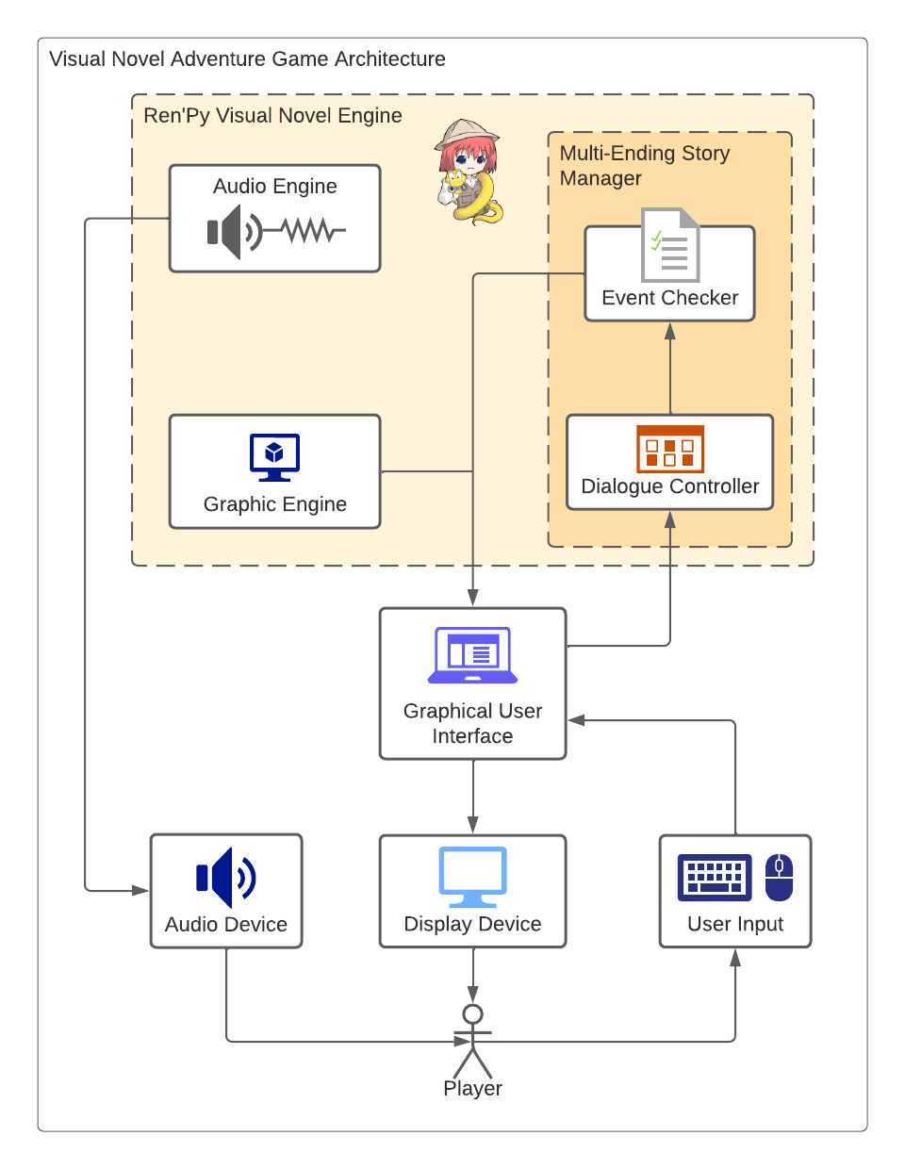

*Figure 1.* Game Architecture

Figure 1 shows the conceptual model for the game's structure, actions, and process on how the Multi-ending Visual Novel works.

For the development of our Visual Novel Adventure Game, a complete Visual Novel system consists of the following basic components, as shown in Figure 1.

The primary beneficiaries of the game are the players who experience the story. User Input is a crucial component of the game, where players interact and input their choices during gameplay. An Audio Device is also necessary to play background music and sound effects during the game. The Ren'Py Visual Novel Engine is the primary framework utilized for the game's development. This software includes several tools such as the Audio Engine, which supports playing music and sound effects, and the Graphic Engine, which allows for the integration of various visual elements like characters and backgrounds. The Multi-Ending Story Manager is another critical component of the game that manages the narrative path that players take based on the choices they make and specific event flags that trigger. Two managers are involved here: the Event Checker, which checks the player's progression in the story, and the Dialogue Controller, which displays appropriate dialogue based on the progression made by the player throughout the game.

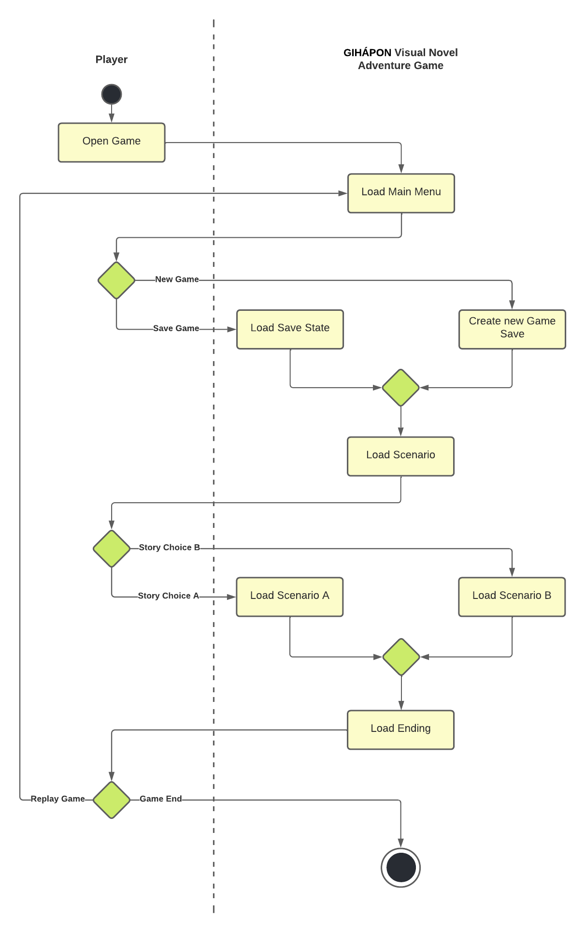

*Figure 2*. Activity Diagram

The activity diagram shown on figure 4 illustrates the interactions between the user and the Visual Novel Game.

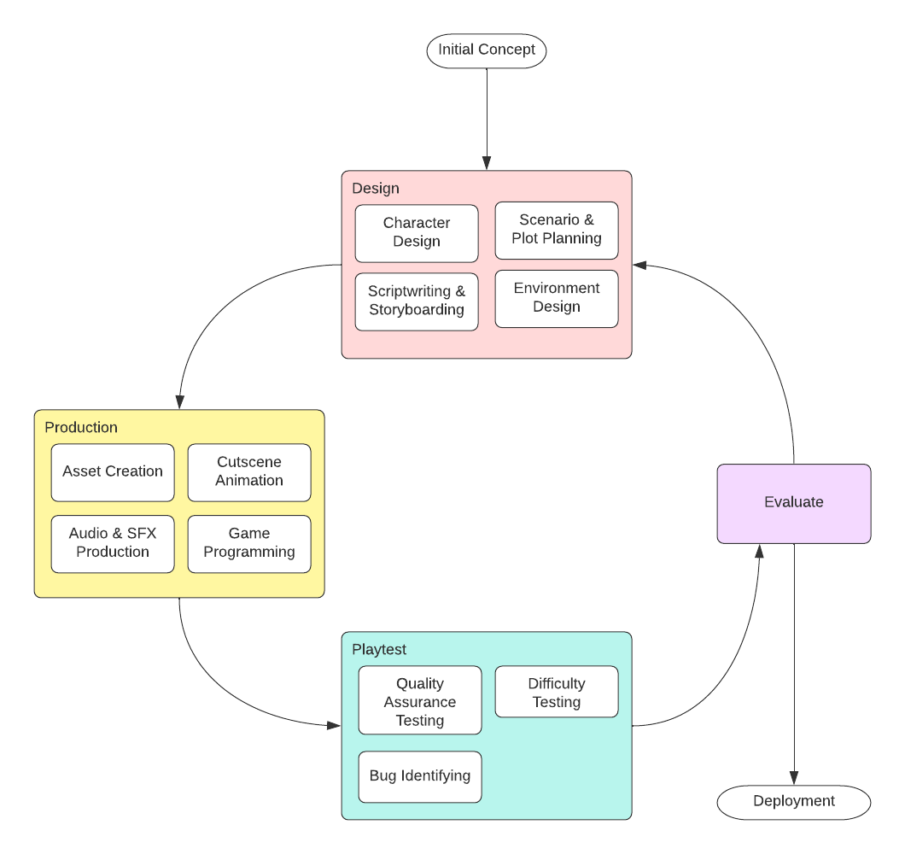

*Figure 3.* Game Development Life Cycle

This study incorporated the use of the Iterative Model for the Game Development Life Cycle. The Iterative Model Game Development Life Cycle improves upon the evaluations made on the previous developed versions of the Game. Iterative model allowed for swift development of prototypes subject to evaluation. It also mitigated any risk relating to permanent decisions made throughout the development. It is beneficial to this study due to its ability to make changes based on feedback on its predecessors.

CHAPTER 4 RESULTS AND DISCUSSION

Implementation

This section delves into the details of GIHÁPON: An Interactive Multi-Ending Visual Novel Adventure Game's implementation. This comprises the game's Pre-production, Production, Post-production stages, and Inputs and Outputs.

Pre-Production

The primary objective aims to develop an interactive visual novel-adventure game with cohesive non-linear narrative multiple endings and branching paths based on the player’s choices.

To achieve the first objective, the researchers had to first write a story. The topic revolved around Filipino struggles; poverty, familial conflicts, business, criminal affairs, politics, and internal conflicts. The researchers then began the pre-production phase of the development. It comprised of concept creation, plot planning, scriptwriting/screenplay, character creation, and environment design.

The concept creation was the first step in Gihapon's development. Researchers involved in the project provided different concepts for the visual novel and proceeded to think of the story and written a script that allowed the game to establish a plot. Before putting pen to paper, plot planning showed the significance of each character through the created outline. Afterward, dialogues were created to be used in the game. The "script" was the foundation of a Visual Novel that served as a reference point throughout the development process.

The artists then started creating characters and planned how they will interact with other characters. Discussing the personalities of the characters helped in the creation of an appropriate visual representation of their roles. Props, color palettes, and backgrounds were all included in this step. The researchers used raw photographs of people and places (taken from the city of Iloilo) as references to create Filipino-inspired 2D characters and environments.

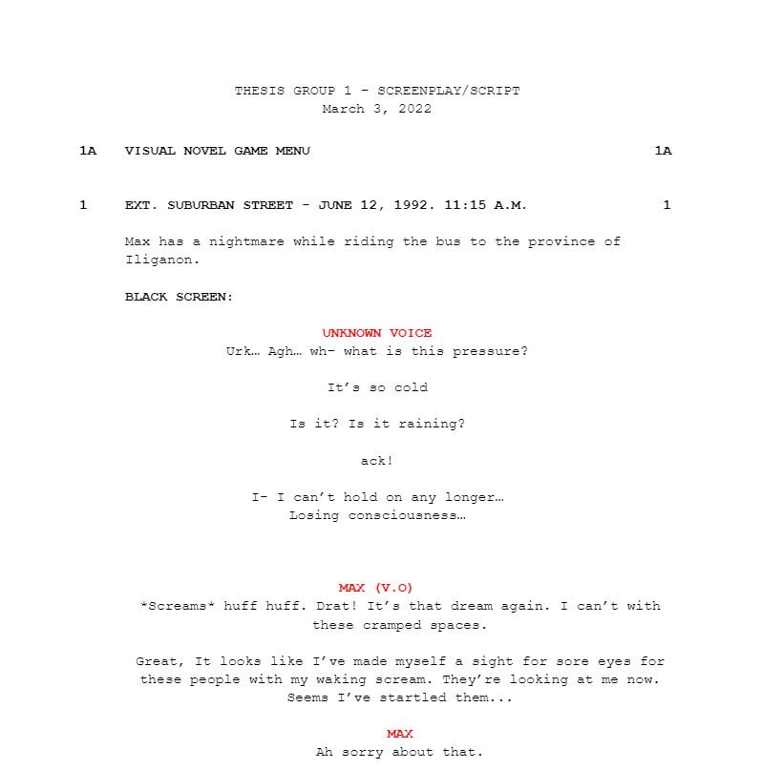*Figure 4.4*. Screenplay of Gihápon

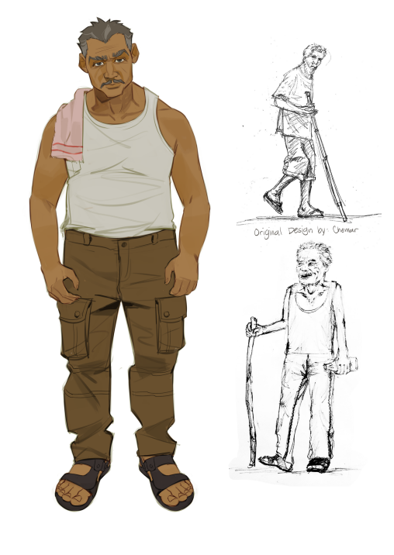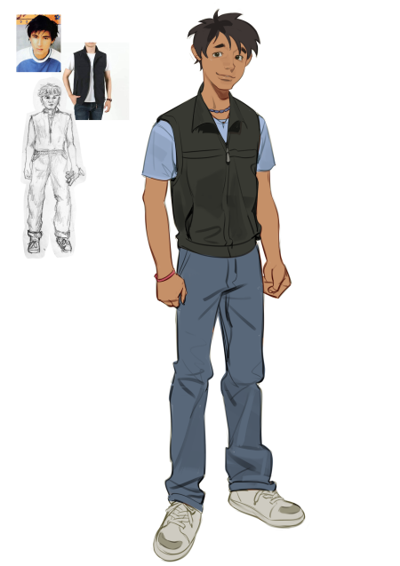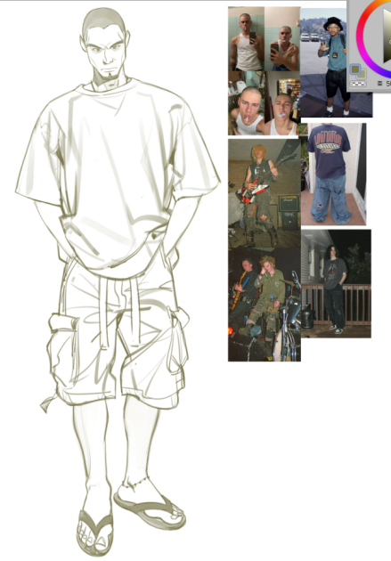

*Figure 4.5*. Character Concept Designs



*Figure 4.6*. Raw Photographs used for background references

Production

This section has two objectives: to add gameplay to the visual novel by developing a puzzle-solving element between story beats, such as but not limited to code riddles and item-based puzzles, and to create a variety of dynamic characters with recognizable iconography that were related to our game plot and will help the player progress through the game.

The visual novel game's production began in this step; it included asset creation, music composition & sound effects production, and game programming. In order to execute the two objectives, the researchers began using the Ren’Py Visual Novel Engine. The designs for the game assets began with a concept to be applied on Ren'py. The artist creates sketches or models to determine the asset's characteristics and proceeds to draw a much more detailed illustration of the game asset. Any piece that appears in a game, such as characters, sounds, texture, or object, is referred to as a game asset. Following that is the creation of music and sound effects. These are made with the FL Studios - A Digital Audio Workshop (DAW) software, which allows the researchers to use the built-in instruments, register new notes, record external sounds, and create or add effects for a composition. At this point, the researchers started writing codes using the ren'py scripts. Ren'Py is built on top of Python, so many statements allow you to use the Python code. The Ren'py engine includes tools for displaying thoughts, conversation, menus, saving and loading, displaying images to the player, and creating puzzle games & multiple endings.

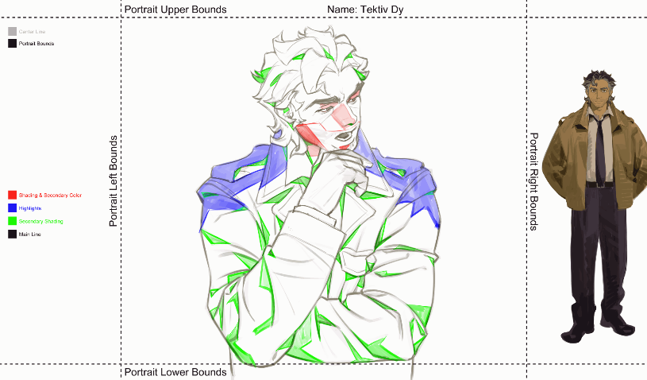

*Figure 4.7.* Character Portrait Asset Creation

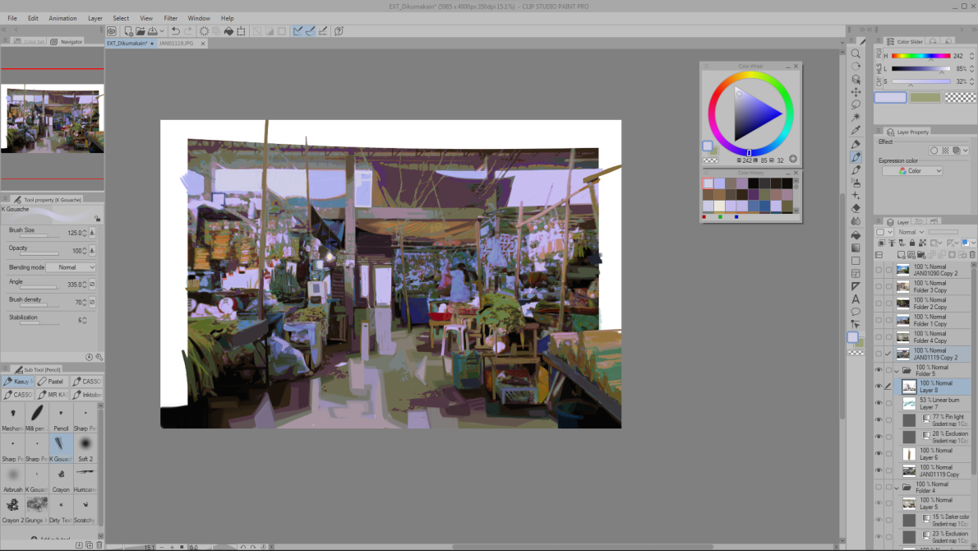

*Figure 4.8.* Illustrating using Clip Studio Paint

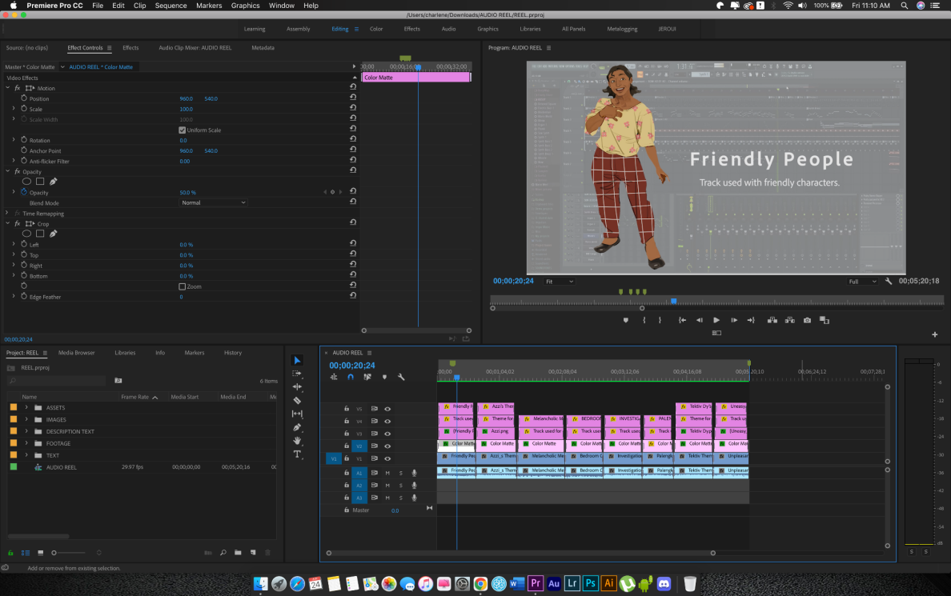

*Figure 4.9*. Video Editing using Adobe Premiere Pro

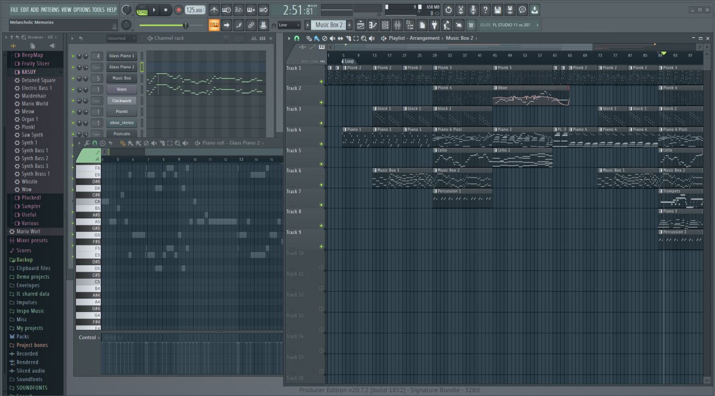*Figure 4.10*. Music Composition using the FL Studios 20

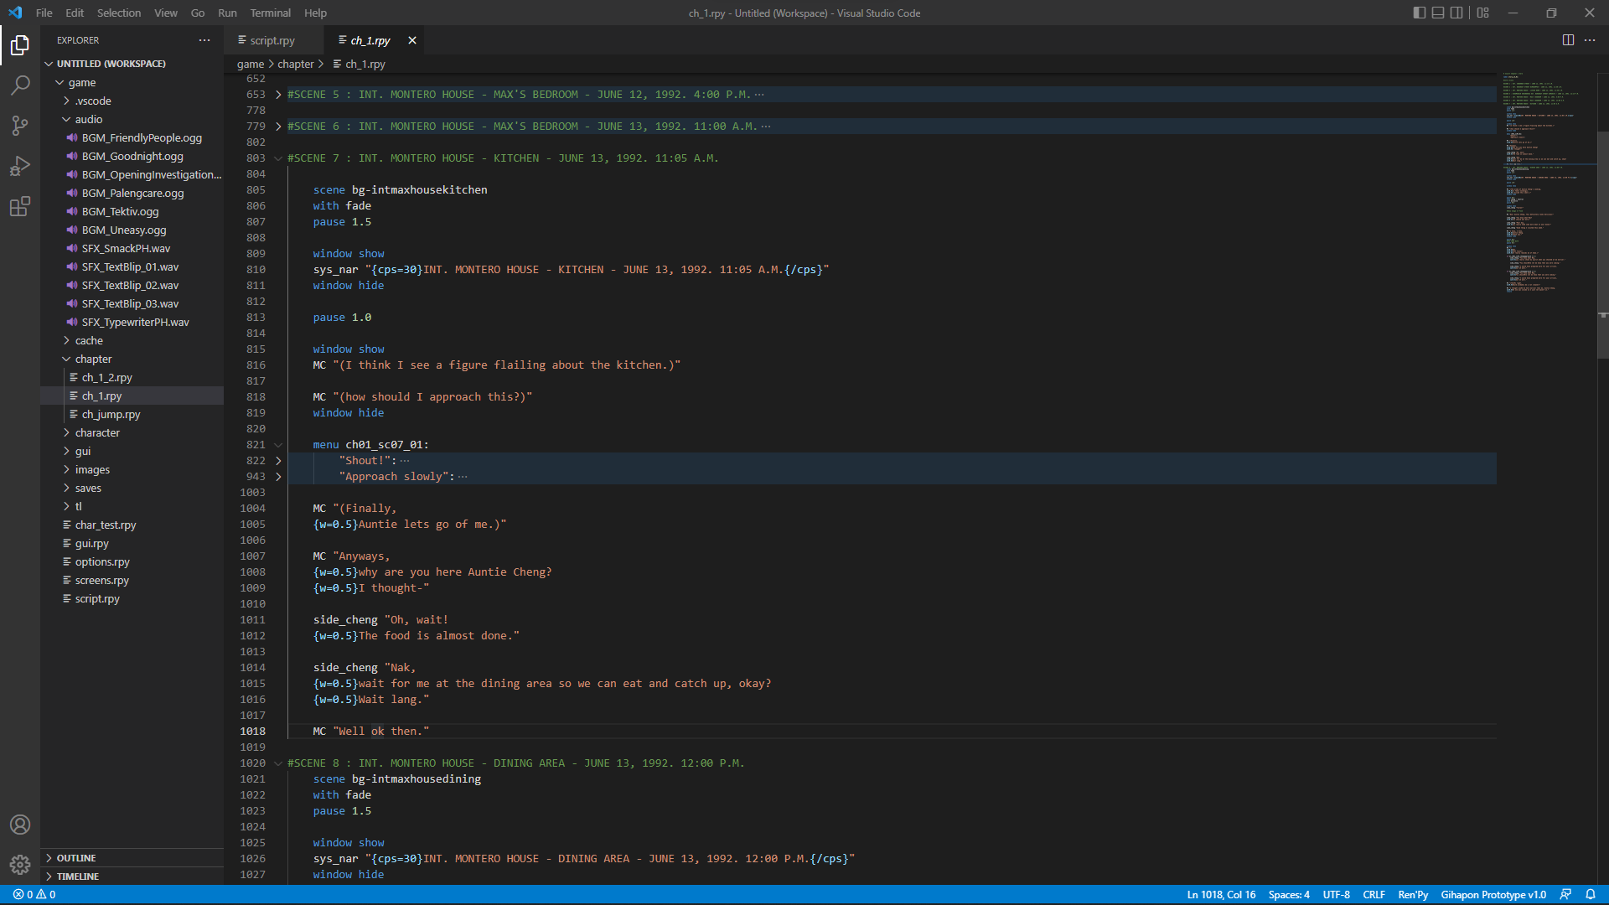*Figure 4.11.* Coding Ren’py script files using VScode

Post-Production

This section includes the fourth objective in Gihápon: Visual Novel Game testing. Game testing is the process of identifying and discovering defects or bugs in a game. The testing compares the game to several requirements that were expected to be meet. This was a necessary step to improve the performance and stability and ensure the overall quality of the game to be played.

After the production stage, the progress either slows down or gets to the phase where the needed software and game assets were considered complete—which was not stating that the project was done. This section focuses on the post-production stage, which focused on polishing, working to fix, and evaluating the game before it was released. Depending on the complexity of the game and how successful the production and pre-production stages were, this phase can take up between 20% and 30% of the total duration of the project. The researchers conducted a testing called the Game User Experience Satisfaction Scale (GUESS). This test was based from feedback from researchers and real users obtained through various functionalities and methods.

The Game User Experience Satisfaction Scale (GUESS) is a relatively new addition to the framework of game user researchers. It has quickly become one of the most prevalent methods for assessing player experience. It gives academics and practitioners in the field a reliable tool for improving the validity and reliability of their research. The GUESS has 55 items with nine subscales and takes about five to ten minutes to complete. Among the subscales are Usability/Playability, Narratives, Play Engrossment, Enjoyment, Creative Freedom, Audio Aesthetics, Personal Gratification, Social Connectivity, and Visual Aesthetics. The results of this multistage process prove that the Game User Experience Satisfaction Scale can be given to video game players with varying levels of experience (the participants self-categorized themselves by newbie, casual, and expert) who play different game genres. When scoring the GUESS, the ratings of all the items per factor were estimated to obtain an average score for each subscale. Furthermore, the average score of each subscale can be added together to acquire a composite score of the Visual Novel Game's satisfaction.

Inputs and Outputs. Inputs included were Keyboard. Players may use this for their character to move around; Mouse. Players may use this to select their answers and to get items since this game is a point-and-click game.

Outputs included were found in the figure below and In-game dialogue.

Main Menu

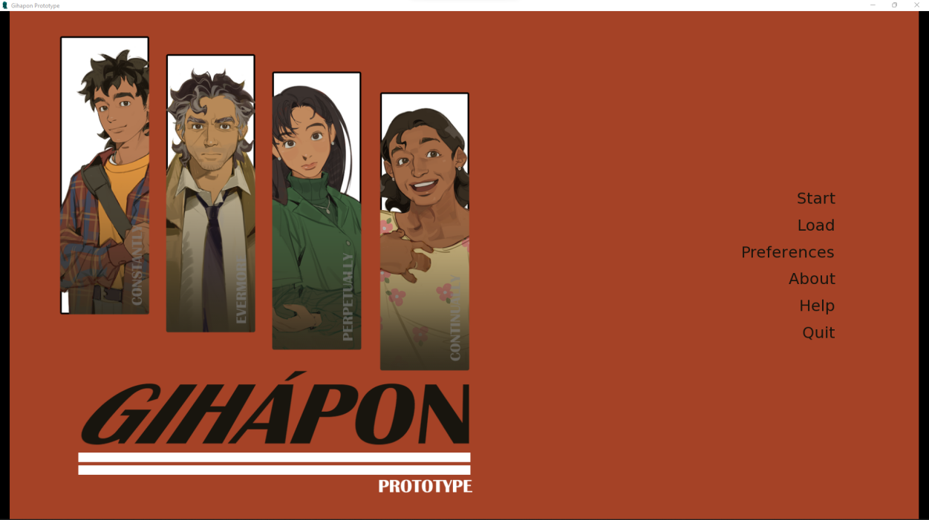

*Figure 4.12*. Main Menu when launching GIHÁPON Visual Novel

In-game Dialogue

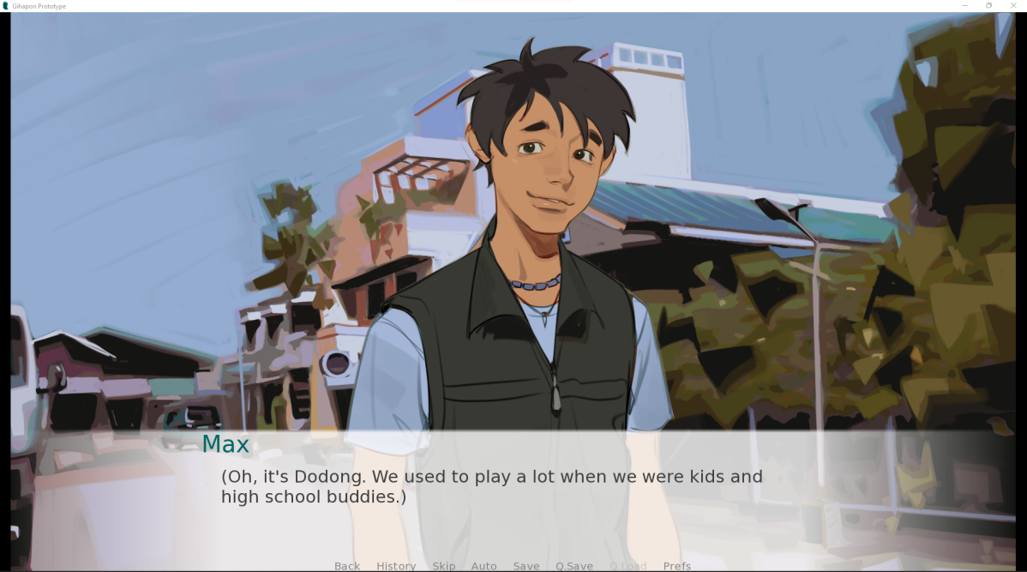

*Figure 4.13*. This is displayed each time the character converses with another character. Max is shown conversing with Dodong in this image.

Multiple Choices

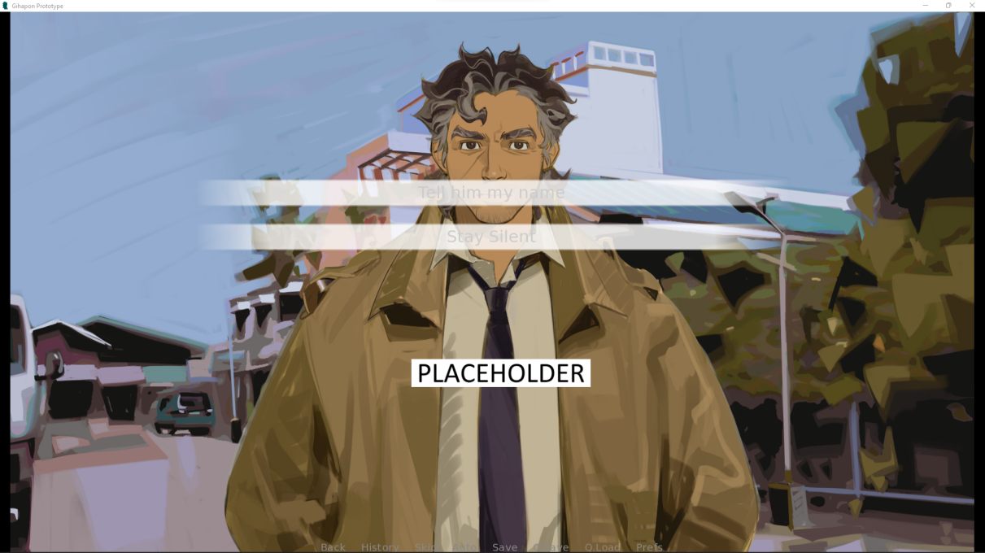

*Figure 4.14*. Choices may come up in dialogue which can lead to a variety of outcomes.

Identifying Bugs

Play-testing was a technique to check quality assurance that occurs at various stages of the video game design process. Unfinished versions of a game were played by a select group of users to iron out flaws in gameplay, level design, and other fundamental elements, as well as to discover and resolve errors and bugs.

Phase one, the self-test. The original prototype was tested by the researchers. While playing, there were open discussions and on-the-spot rules and idea modifications. The game resources used for this test were quite simple. The researchers, may then switch to online formats if the paper test was successful. If not, redesign the game on paper and play-test it again before putting it online. In phase two, after the initial play-tests/revisions with the team, it is time to enlist some other viewpoints. While others enter and participate in the game, the researchers observed. The respondents can now assess the game's visuals, programmed interactions, and actual content. After completing the VN, the participants rate it and provide feedback by responding to a questionnaire created by the researchers. The five researchers and respondents from Iloilo City tested Gihapon, and they found no bugs or glitches. The Visual Novel does a good job at executing the puzzle component and the three different endings.

Results Interpretation and Analysis

The study is evaluated using the Game User Experience Satisfaction Scale (GUESS), only employing the eight subscales (“Social Connectivity” is not relevant to our game). The GUESS was used to test content validity, internal consistency, and convergent and discriminant validity. Usability/Playability, Narratives, Play Engrossment, Enjoyment, Creative Freedom, Audio Aesthetics, Personal Gratification, and Visual Aesthetics are the determining factors involved. The results are compiled into means after the total rating of each criterion is obtained.

A total of 24 responses were collected from the evaluation questionnaire for GIHÁPON: An Interactive Multi-Ending Visual Novel Adventure Game. The respondents for this study are only in the City of Iloilo. Through our gathered data, the respondents are in the range of 13-23 years old. There are 33.3% Female, 62.5% Male, and 4.2% other respondents. There are 12.5% Newbie Players, 58.3% Casual Players, and 29.2% Hardcore players.

|  |  |
| --- | --- |
| Gender | Percentage |
| Male | 63.5% |
| Female | 33.3% |
| Other | 4.2% |

*Table 1*. Gender of the respondents’ percentage

|  |  |
| --- | --- |
| Type of Video Game Player | Percentage |
| Newbie Gamer | 12.5% |
| Casual Gamer | 58.3% |
| Hardcore Gamer | 29.2% |

*Table 2*. Type of Video Game Player percentage

| Interpretation | Value | Range |
| --- | --- | --- |
| Strongly Agree | 7 | 6.01 – 7.00 |
| Agree | 6 | 5.20 – 6.00 |
| Somewhat Agree | 5 | 4.30 – 5.19 |
| Neither Agree or Disagree | 4 | 3.50 – 4.29 |
| Somewhat Disagree | 3 | 2.70 – 3.49 |
| Disagree | 2 | 1.80 – 2.69 |
| Strongly Disagree | 1 | 1.00 - 1.79 |

*Table 3*. 7-point Likert scale scoring range

| Criteria | Mean | Interpretation |
| --- | --- | --- |
| Usability/Playability | 6.62 | Strongly Agree |
| Narratives | 6.74 | Strongly Agree |
| Play Engrossment | 5.98 | Agree |
| Enjoyment | 5.99 | Agree |
| Creative Freedom | 6.54 | Strongly Agree |
| Audio Aesthetics | 6.87 | Strongly Agree |
| Personal Gratification | 6.69 | Strongly Agree |
| Visual Aesthetics | 7.00 | Strongly Agree |
| Overall Mean | 6.55 | Strongly Agree |
| Composite Score | 52.53 |  |

*Table 4*. Evaluation Results of the Interactive

Multi-Ending Visual Novel Adventure Game Using the Game User Experience Satisfaction Scale (GUESS).

The choices on the 7-Likert scale, which was used to gauge the viewpoint being studied, were “Strongly Disagree” (1), “Disagree” (2), “Somewhat Disagree” (3), “Neither Agree or Disagree” (4), “Somewhat Agree” (5), “Agree” (6), and “Strongly Agree” (7).

The information gathered from the GUESS was examined to obtain the mean scores and interpreted using the 7-point Likert scale scoring range.

|  |  |  |
| --- | --- | --- |
| Usability/Playability | Mean | Interpretation |
| 1. I think it is easy to learn how to play the game. | 6.58 | Strongly Agree |
| 1. I find the controls of the game to be straightforward. | 6.79 | Strongly Agree |
| 1. I always know how to achieve my goals/objectives in the game. | 6.62 | Strongly Agree |
| 1. I find the game’s interface to be easy to navigate. | 6.75 | Strongly Agree |
| 1. I do not need to go through a lengthy tutorial or read a manual to play the game. | 6.58 | Strongly Agree |
| 1. I find the game’s menus to be user-friendly. | 6.79 | Strongly Agree |
| 1. I feel the game trains me well in all of the controls. | 6.41 | Strongly Agree |
| 1. I always know my next goal when I finish an event in the game. | 6.41 | Strongly Agree |
| 1. I feel the game provides me the necessary information to accomplish a goal within the game. | 6.62 | Strongly Agree |
| 1. I think the information provided in the game (e.g., on-screen messages, help) is clear. | 6.58 | Strongly Agree |
| 1. I feel very confident while playing the game. | 6.79 | Strongly Agree |
| Overall Mean | 6.63 | Strongly Agree |

*Table 5*. Results of Usability/Playability

In usability/playability, a “Strongly Agree” interpretation with a mean score of 6.63 was accumulated. This implies that the game can be played with certain goals or aims in mind, with little to no cognitive interference from the user interfaces and controllers, and with these conditions met.

|  |  |  |
| --- | --- | --- |
| Narratives | Mean | Interpretation |
| 1. I think the characters in the game are well-developed. | 6.87 | STRONGLY AGREE |
| 1. I am captivated by the game’s story from the beginning. | 6.75 | STRONGLY AGREE |
| 1. I enjoy the story provided by the game. | 6.83 | STRONGLY AGREE |
| 1. I can identify with the characters in the game. | 6.75 | STRONGLY AGREE |
| 1. I am emotionally moved by the events in the game. | 6.58 | STRONGLY AGREE |
| 1. I am very interested in seeing how the events in the game will progress. | 6.70 | STRONGLY AGREE |
| 1. I can clearly understand the game’s story. | 6.70 | STRONGLY AGREE |
| Overall Mean | 6.74 | STRONGLY AGREE |

*Table 6*. Results of Narratives

For the narratives, “Strongly Agree” interpretation was gathered with a 6.74 mean score. The game's narrative elements—such as its plot and characters—was able to hold the player's attention and influencing their emotions.

|  |  |  |
| --- | --- | --- |
| Play Engrossment | Mean | Interpretation |
| 1. I feel detached from the outside world while playing the game. | 5.79 | AGREE |
| 1. I do not care to check events that are happening in the real world during the game. | 5.54 | AGREE |
| 1. I cannot tell that I am getting tired while playing the game. | 5.87 | AGREE |
| 1. Sometimes I lose track of time while playing the game. | 6.12 | STRONGLY AGREE |
| 1. I temporarily forget about my everyday worries while playing the game. | 6.08 | STRONGLY AGREE |
| 1. I tend to spend more time playing the game than I have planned. | 6.33 | STRONGLY AGREE |
| 1. I can block out most other distractions when playing the game | 6.08 | STRONGLY AGREE |
| 1. Whenever I stopped playing the game I cannot wait to start playing it again. | 6.08 | STRONGLY AGREE |
| Overall Mean | 5.99 | AGREE |

*Table 7*. Results of Play Engrossment

In play engrossment, it was able to gather a mean score of 5.99 that interprets as “Agree”. The game was able to capture the player’s attention and interest.

|  |  |  |
| --- | --- | --- |
| Enjoyment | Mean | Interpretation |
| 1. I think the game is fun. | 6.91 | STRONGLY AGREE |
| 1. I enjoy playing the game. | 6.87 | STRONGLY AGREE |
| 1. I feel bored while playing the game. | 3.62 | NEITHER AGREE OR DISAGREE |
| 1. I am likely to recommend this game to others. | 6.83 | STRONGLY AGREE |
| 1. If given the chance, I want to play this game again. | 5.74 | AGREE |
| Overall Mean | 5.99 | AGREE |

*Table 8.* Results of Enjoyment

In enjoyment, “Agree” interpretation was accumulated with a 5.99 average. The player's perception of their enjoyment and satisfaction from playing the game were achieved.

|  |  |  |
| --- | --- | --- |
| Creative Freedom | Mean | Interpretation |
| 1. I feel the game allows me to be imaginative. | 6.54 | STRONGLY AGREE |
| 1. I feel creative while playing the game. | 6.5 | STRONGLY AGREE |
| 1. I feel the game gives me enough freedom to act how I want. | 6.37 | STRONGLY AGREE |
| 1. I feel the game allows me to express myself. | 6.41 | STRONGLY AGREE |
| 1. I feel I can explore things in the game. | 6.5 | STRONGLY AGREE |
| 1. I feel my curiosity is stimulated as a result of playing the game. | 6.79 | STRONGLY AGREE |
| 1. I think the game is unique or original. | 6.7 | STRONGLY AGREE |
| Overall Mean | 6.54 | STRONGLY AGREE |

*Table 9*. Results of Creative Freedom

For creative freedom, an average score of 6.54 was obtained with a “Strongly Agree” interpretation. The game was able to foster the player's imagination and curiosity.

|  |  |  |
| --- | --- | --- |
| Audio Aesthetic | Mean | Interpretation |
| 1. I enjoy the sound effects in the game. | 6.87 | STRONGLY AGREE |
| 1. I enjoy the music in the game. | 6.83 | STRONGLY AGREE |
| 1. I feel the game’s audio (e.g., sound effects, music) enhances my gaming experience. | 6.87 | STRONGLY AGREE |
| 1. I think the game’s audio fits the mood or style of the game. | 6.91 | STRONGLY AGREE |
| Overall Mean | 6.87 | STRONGLY AGREE |

*Table 10*. Results of Audio Aesthetics

In audio aesthetics, “Strongly Agree” interpretation is accumulated with a 6.87 mean score. The game's various auditory features, such as the sound effects, had a positive impression on the players.

|  |  |  |
| --- | --- | --- |
| Personal Gratification | Mean | Interpretation |
| 1. I am in suspense about whether I will succeed in the game. | 6.58 | STRONGLY AGREE |
| 1. I feel successful when I overcome the obstacles in the game. | 6.7 | STRONGLY AGREE |
| 1. I want to do as well as possible during the game. | 6.79 | STRONGLY AGREE |
| 1. I am very focused on my own performance while playing the game. | 6.66 | STRONGLY AGREE |
| 1. I feel the game constantly motivates me to proceed further to the next stage or level. | 6.75 | STRONGLY AGREE |
| 1. I find my skills gradually improve through the course of overcoming the challenges in the game. | 6.66 | STRONGLY AGREE |
| Overall Mean | 6.69 | STRONGLY AGREE |

*Table 11.* Results of Personal Gratification

For personal gratification, an average score of 6.69 was obtained and a “Strongly Agree” interpretation. The game's motivational elements, such as the challenge, which foster a sense of accomplishment in the player and encourage them to keep playing the game and succeed, were achieved.

|  |  |  |
| --- | --- | --- |
| Visual Aesthetic | Mean | Interpretation |
| 1. I enjoy the game's graphics. | 7.00 | STRONGLY AGREE |
| 1. I think the graphics of the game for the mood or style of the game. | 7.00 | STRONGLY AGREE |
| 1. I think the game is visually appealing. | 7.00 | STRONGLY AGREE |
| Overall Mean | 7.00 | STRONGLY AGREE |

*Table 12.* Results of Visual Aesthetics

In visual aesthetics, a “Strongly Agree” interpretation with a perfect average score of 7 was accumulated. Players were drawn to play and continue the game due to its visuals.

CHAPTER 5 SUMMARY, CONCLUSION, AND RECOMMENDATION

Summary of the Proposed Study Design and Implementation

To convey the Filipino experience and customs, the Visual Novel genre was utilized to deliver these stories. The primary goal of the " Gihápon" Visual Novel was to create an interactive fiction video game with puzzle-solving aspects, a text-based plot, and interactivity supported by stable or sprite-based images centered around a typical Filipino lifestyle. It included several branching pathways with three distinct endings and it can be played on Windows operating systems.

Gihápon's development started with the creation of a concept. Researchers gave the visual novel several notions and then constructed a screenplay that enabled the game to establish a plot. The creation of dialogue then followed it acted as a reference throughout the development phase. The creators then began developing characters and figuring out how they will relate to one another. The creation of assets, the production of music and sound effects, and game programming were the steps in the visual novel game's production phase. Post-production started with polishing, conducting corrections, and assessing the game before its launch.

This study aimed to provide entertainment and analytical purposes to the users. Making and designing an interactive visual novel adventure game with multiple endings may help people enhance their analytical thinking abilities when solving problems.

Summary of Findings

Testing was necessary to check for usability issues and check if the system was completely functional. An online questionnaire was conducted among 3 self-identified groups of gamers (i.e., newbie, casual, and hardcore). There were 24 participants in the study.

*Materials*. Using Google Forms, an online survey tool, the questionnaire was created and the results were recorded on a 7-point, unipolar scale with response anchors. The demographic questions and a number of statements from the GUESS item pool were included in the online questionnaire. (https://docs.google.com/forms/d/e/1FAIpQLSfgKVGyMcMevi8CByy4O6buCxEYXyHWmlHjL5RDhCxKvrrJ6A/viewform)

*Procedure*. Participants were asked to register the URL of the questionnaire provided by the researchers. They began by stating that the information collected through this particular questionnaire which was strictly confidential and was only used for research purposes. Participants had to provide basic information about themselves before the evaluation process (e.g., name, gender, age, and what type of video game player they are). After that, the participants proceeded to the game evaluation phase, where they were given a 7-point rating scale and asked to rate how much they agreed or disagreed with each statement about the game.

*Results*. To determine the average score for each subscale, the total items for each factor must be combined. In order to get a composite score for video game satisfaction, the average scores for each subscale are combined together. Usability/Playability has 6.62, Narratives has 6.74, Play Engrossment has 5.98, Enjoyment has 5.99, Creative Freedom has 6.54, Audio Aesthetics has 6.87, Personal Gratification has 6.69, and Visual Aesthetics has 7 with a composite score of 52.53 (overall mean: 6.55). The higher the average score, the more satisfying the game. This indicates that the Visual Novel Game was successfully implemented and enjoyed by the players.

Conclusions

The researchers successfully completed the development of GIHAPON, an interactive multi-ending Visual Novel Adventure Game using the Ren'Py Visual Novel Engine. This study successfully developed an interactive visual novel game with a narrative-driven storyline through character interaction and incorporating Adventure Game Genre elements such as multiple branching paths and three different endings. The game's story was set in a fictional Filipino Town with characters portraying a variety of typical Filipino traits.

The researchers were able to achieve the objectives set for the study after the evaluation and specific observations were done. The following conclusions were drawn from the results of this study:

1. A gameplay was applied to the visual novel; a puzzle-solving element between story beats, such as code riddles and item-based puzzles.

Timeline:

* Max needs to investigate the room but it’s locked.

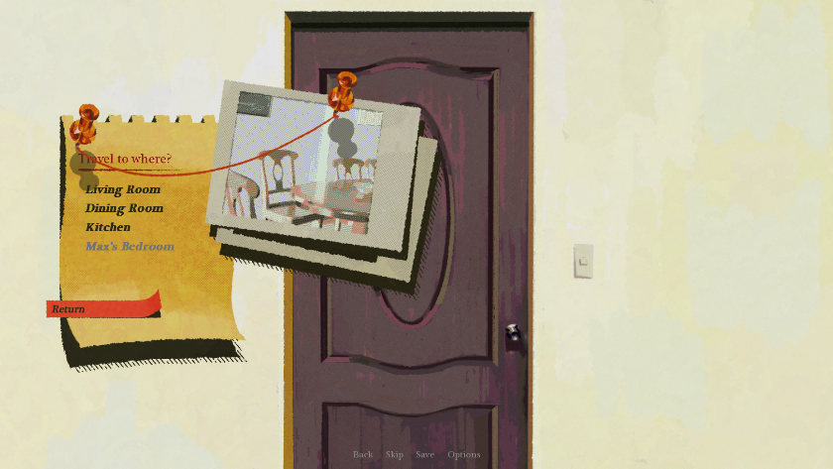

* The key is in a safe box; it needs a code. 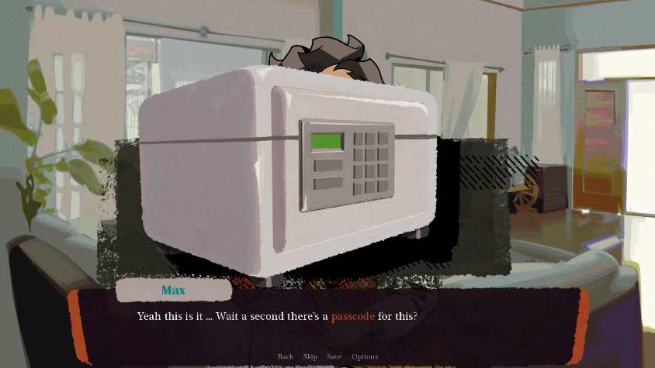
* Find clues at different locations. A notebook at the kitchen is found.

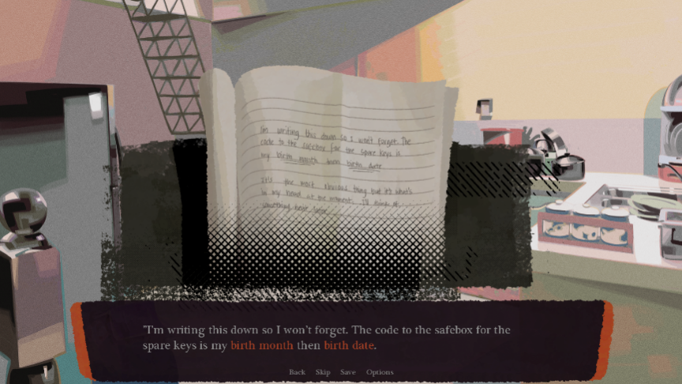

* Check the Dining Room for some clues. Notice the encircled date on the calendar.

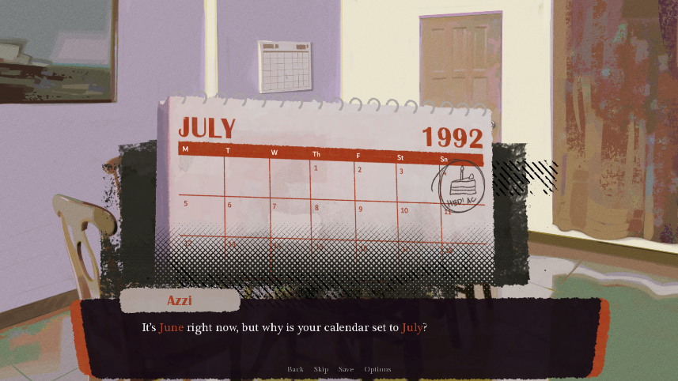

* Enter the code and open the safe box.

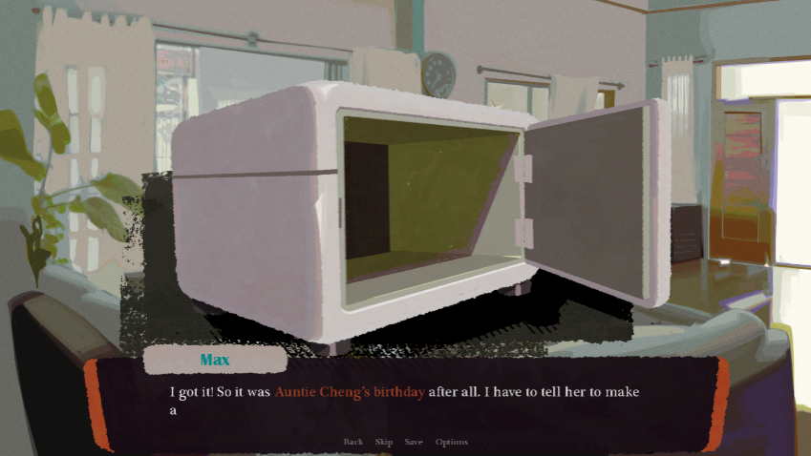

* The player successfully opened Max’s door.

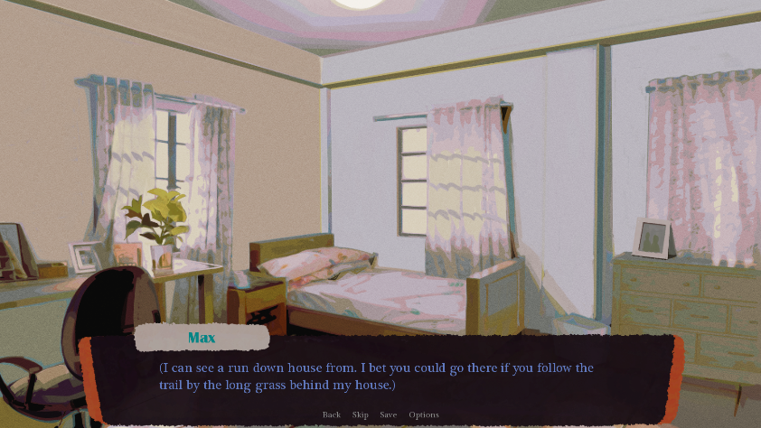

2. A variety of dynamic characters were made with recognizable iconography that were related to the game plot and aids the player's game progression.

3. Results were acquired after the evaluation for the final output using the Game User Experience Satisfaction Scale (GUESS). A composite score of 52.53 was gathered (6.55 as the overall mean).

Recommendations

Our study, "Gihápon: An Interactive Multi-Ending Visual Novel Adventure Game," was an overall success, however, there were areas that could be improved upon in future iterations of the game. One suggestion would be to change the names of the characters to make them more unique and memorable for players. Additionally, localization of the game into Tagalog and Hiligaynon would be beneficial to reach a wider audience. Finally, publishing the game on popular platforms such as Google Play Store and App Store would increase its accessibility to players.

References:

Bashova, K., & Pachovski, V. (2013). Visual novel.<https://doi.org/10.13140/RG.2.1.5007.6405>

Bashova, K., & Pachovski, V. (2014). Poetry as a Visual Novel – a Multimedia Project.

Camingue, J., Carstensdottir, E., & Melcer, E. F. (2021). What is a Visual Novel? Proceedings of the ACM on Human-Computer Interaction, 5(CHI PLAY), 285:1-285:18.<https://doi.org/10.1145/3474712>

Carlson, A. (n.d.). Making the Choice: Are Multiple Endings a Good Thing? - Hardcore Gamer. Retrieved November 16, 2022, from<https://hardcoregamer.com/features/articles/opinion/making-the-choice-are-multiple-endings-a-good-thing/104998/>

Cavallaro, D. (2010). Anime and the visual novel: Narrative structure, design and play at the crossroads of animation and computer games. McFarland & Co.

Consalvo, M., & Staines, D. (2021). Reading Ren’Py: Game Engine Affordances and Design Possibilities. Games and Culture, 16(6), 762–778.<https://doi.org/10.1177/1555412020973823>

Detroit: Become Human | Official Site | Quantic Dream. (n.d.). Retrieved November 16, 2022, from<https://www.quanticdream.com/en/detroit-become-human>

Quantic Dream—Official Site. (n.d.). Retrieved November 16, 2022, from<https://www.quanticdream.com/en>

Zero Escape: Nine Hours, Nine Persons, Nine Doors. (n.d.). Zero Escape Wiki. Retrieved November 16, 2022, from<https://zeroescape.fandom.com/wiki/Zero_Escape:_Nine_Hours,_Nine_Persons,_Nine_Doors>

Phan, M. H., Keebler, J. R., & Chaparro, B. S. (2016). The Development and Validation of the Game User Experience Satisfaction Scale (GUESS). Human Factors, 58(8), 1217–1247.<https://doi.org/10.1177/0018720816669646>

Phoenix Wright: Ace Attorney for Nintendo DS (2005). (n.d.). MobyGames. Retrieved November 16, 2022, from<https://www.mobygames.com/game/nintendo-ds/phoenix-wright-ace-attorney>

King, W. (2003). Andrew Rollings and Ernest Adams on game design.<https://www.academia.edu/892187/Andrew_Rollings_and_Ernest_Adams_on_game_design>

The Portopia Serial Murder Case (Visual Novel)—TV Tropes. (n.d.). Retrieved November 16, 2022, from<https://tvtropes.org/pmwiki/pmwiki.php/VisualNovel/ThePortopiaSerialMurderCase>

The Walking Dead: Season 1 DRM-Free Download—Free GOG PC Games. (n.d.). Retrieved November 16, 2022, from<https://freegogpcgames.com/1358/the-walking-dead-season-1/>

Telltale Games. (n.d.). Retrieved November 16, 2022, from<https://telltale.com/>

Valencia-García, R., Lagos-Ortiz, K., Alcaraz-Mármol, G., Del Cioppo, J., & Vera-Lucio, N. (2016). Technologies and innovation: Second International Conference, CITI 2016, Guayaquil, Ecuador, November 23-25, 2016, proceedings. Springer.

Villariaza, B. (2015, April 8). OPINION: Exogenesis and the Visual Novel fandom in the Philippines. Anime Pilipinas.<https://www.animepilipinas.com/2015/04/09/exogenesis-and-the-visual-novel-fandom-in-the-philippines/>

Wardana, P. S. A. (n.d.). The Ren’Py Visual Novel Engine. Retrieved November 16, 2022, from<https://www.renpy.org/>